**Year 11 Information Technology - Unit 1 – Outcome 3 – ICT Website**

**Practice SAC Task – Part 1:**

**Brainstorming, Bibliography-ing, Researching, Surveying & Opinion-ing.**

|  |  |  |  |
| --- | --- | --- | --- |
| **Topic:** | 3D Printing | **Students in Group:** | We’re gonna do this as a class |

1. **Brainstorm**

Use Inspiration to generate a brainstorm based on what you know or think about the topic.

The brainstorm should cover the following questions.

* What
* Where
* How
* Why
* Pros
* Cons
* Legal issues
* Social issues
* Environmental issues
* Ethical issues
* How it affects individuals
* How it affects organisations
* How it affects governments
* Where to get more info about the topic- Secondary source
* What survey questions can I ask the class about the topic – Primary source
* Website design ideas

Below is an example of how you might start. You could create a bubble for each and then add your own thoughts to them.

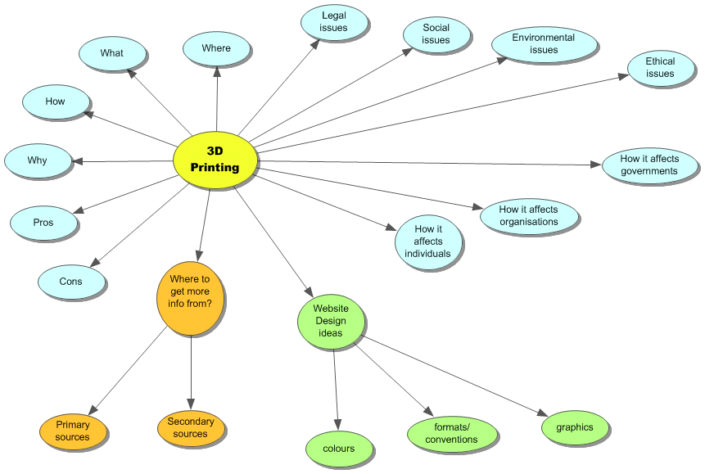

You would then upload your brainstorm as an Inspiration file or a graphic onto your final website.

1. **Bibliography**

Before we start researching, we need to understand how to write a Bibliography.

It should be in this format below:

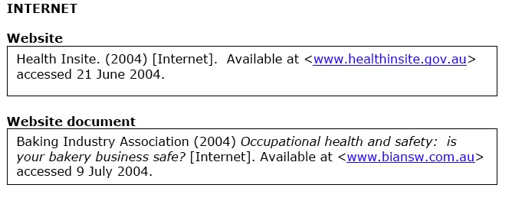

When you start researching the topic, make sure you write down all websites and sources you get your information from in a bibliography.

You can use this table below to help set it up:

|  |  |  |  |  |
| --- | --- | --- | --- | --- |
| **Website name** | **Year created** | **Website address** | **Date accessed** | **Bibliography** |
| *Eg; Mr. Lee’s Website* | *Eg; 2012* | *Eg;* [*http://www.mrlee.it*](http://www.mrlee.it) | *23 March 2013* | *Mr. Lee’s Website (2012) [Internet]. Available at* [*www.mrlee.it*](http://www.mrlee.it) *accessed 23 March 2013.* |
|  |  |  |  |  |
|  |  |  |  |  |
|  |  |  |  |  |
|  |  |  |  |  |
|  |  |  |  |  |

The last column (Bibliography) is the only thing you should eventually put in the bibliography section of your website.

1. **Researching about the ICT Topic**

Now you have done a brain storm and understand how to write a bibliography, it’s time to start researching the topic.

Fill in the tables below, making sure each source you get your information from is included in your bibliography in Part 2.

|  |  |
| --- | --- |
| **What is it?** | |
| Description |  |
| Why was it created |  |
| History |  |
| Types of technology involved (types/models/versions offered) |  |

|  |  |
| --- | --- |
| **Capabilities of technology involved** | |
| How it works |  |
| What is needed to make it work |  |
| Limitations |  |
| Future plans |  |

|  |  |  |
| --- | --- | --- |
| **Issues about the ICT Topic** | | |
| **Issues** | **Positives** | **Negatives** |
| Legal |  |  |
| Social |  |  |
| Environmental |  |  |
| Ethical |  |  |

|  |  |  |  |
| --- | --- | --- | --- |
| **Stakeholders involved – How does it affect them** | | | |
| **Stakeholder** | **Responsibilities** | **Positives** | **Negatives** |
| Individuals/users |  |  |  |
| Organisations |  |  |  |
| Governments |  |  |  |

1. **Surveying the class for statistical data**

You need to make a survey for other students in class to complete.

Use this data into a spreadsheet and create a chart showing statistics on class opinions/usage

Before you begin, it would help to think of what questions you would ask them.

You might start with “closed” Multiple choice questions and questions where they must rate from high to low.

Afterwards you would also want to include some “open questions” where the person surveyed must write a short answer to your question.

**Multiple choice/rating questions (at least 5)**

|  |  |
| --- | --- |
| **Question** | **Multiple choice answers or ratings** |
|  |  |
|  |  |
|  |  |
|  |  |
|  |  |

**Short answer questions (at least 2)**

|  |
| --- |
|  |
|  |

Once you have come up with your questions, you should go to Google Drive and set up an account to create a Survey, or use a site like Surveymonkey.com.

Afterwards, send the survey link to the teacher at [imyourteacher@gmail.com](mailto:imyourteacher@gmail.com). The teacher will put it on a website for everyone to be able to access and answer easily.

**Ok, so everyone’s answered my survey. What now?**

You need to extract that data into a spreadsheet, and create a chart, work out percentages etc. You can then put that information into your website and refer to the statistics when writing about the ICT issue.

1. **Finally, your opinion on the subject - Evaluation.**

Now that you have (take deep breath) - brainstormed, done the research, created the survey, got the statistics from the class, recorded in a bibliography the primary and secondary sources, and analysed and compared all the facts and opinions, the final thing is to **Evaluate it!**

That means: Write a summary of your own opinion of the ICT issue.

This should be at least 500 words long.

|  |
| --- |
|  |

**Done! Now what?** Now you just have to 1. Chuck the whole dang thing in a website you’ve designed, site mapped, layout diagrammed, and built; and 2. Record work done, who did it and how long in your Project Management planner/Gantt chart; and you’re done! ☺